# Exploring the census: a resource co-produced with Y8 students

**Year 8 students from Radyr Comprehensive School in Cardiff used interactive websites that display summary data from censuses to discover interesting facts about their local area and compare them with other parts of England and Wales.**

**This activity pack tells you what they found particularly interesting and suggests similar explorations you can try for yourselves.**

It is based on explorations of two interactive websites:

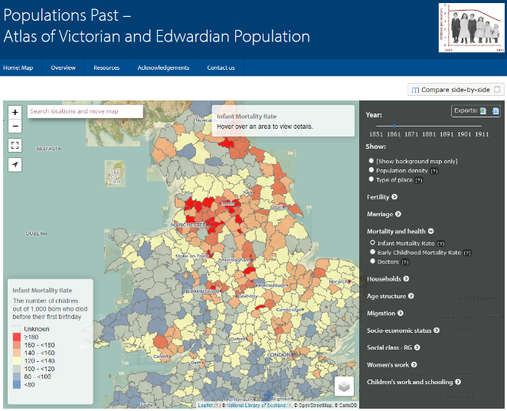[www.PopulationsPast.org](http://www.PopulationsPast.org) maps summary data from 1851 to 1911 censuses.

* Choose what to display using the menu on the right. Click on the arrow to get options and then click on the circle to choose
* Change year using the slider at the top of the menu
* Zoom in and out using the buttons at the top left, or search for a place
* Red is always high values, blue is always low values
* Compare two dates or two measures using the side-by-side button at the top right

[www.datashine.org.uk](http://www.datashine.org.uk) maps summary data for the 2011 census.

* 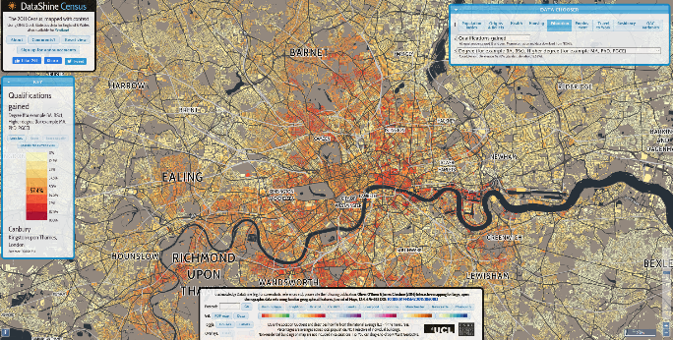Use the data chooser in the top right to select data
* Zoom in and out or search for a postcode
* Click Toggle Houses in the bottom panel to colour the whole graph
* Look carefully at the key, because sometimes red is high, and sometimes it’s low!

**We have used green text to highlight the things the students found interesting, black text for explanations by academics, and purple for suggested activities.**

This resource was co-produced by Dr Alice Reid and colleagues, of the Department of Geography, University of Cambridge, as part of the project ‘Engaging the Public in Census 2021 project: Census taking over time – a project by schools and for schools’, funded by the Arts and Humanities Research Council (AHRC) and Economic and Social Research Council (ESRC), part of UK Research and Innovation.

# Education

**The Year 8s were particularly interested to see what children their own age might have been doing in the nineteenth century.**

Today young people have to stay in full-time education until they are 18, but in the middle of the nineteenth century school was not compulsory. The first Education Act in 1870 established local school boards which could build and manage schools, and the 1880 Education Act made school compulsory between the ages of 5 and 10 years. However the continued need to pay fees until 1891 meant that not all children could afford to attend school. The minimum school leaving age was increased to 11 years in 1893 and to 12 years in 1899. These changes meant that more and more children attended school, stayed at school longer, and that more resources were available for schools between 1851 and 1911.

[www.PopulationsPast.org](http://www.PopulationsPast.org) shows a measure of ‘children (aged 4-13) per teacher’. This would measure class size if all children went to school until age 13, but not all children went to school, so this measure is also high where many children did not attend school.

**Vera compared children per teacher in Swansea and Cardiff, noting the effect of changing educational provision.**

**She said:**

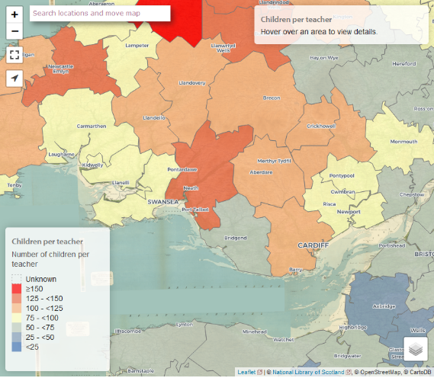

In Swansea 1861 the ratio between teachers and pupils is astonishing. Each teacher would have around 85 kids to teach. However, in Cardiff 1861 the ratio between teachers and children was even bigger. This leads to one teacher having to teach 106 kids. As education improved over the years it le~~a~~d to one teacher only having to teach around 32 kids in Cardiff 1901. Furthermore, in Swansea the numbers also decreased massively with one teacher having to teach 28 kids.

## Activity:

**Look at the number of children per teacher in your area in 1861. Did it fall dramatically by 1901?**

# Children’s work

Children not at school may have been earning money or doing housework at home.

**Isabella, Oscar, Imogen and Seb noticed that there were strong geographical patterns in the percentages of children who were doing paid work.** **Imogen noticed that there were very few working children in London, but far more in the rural areas to the north and west of London. Seb pointed out that the most northerly parts of England had low percentages of children at work.**

**Oscar said:**

In 1861 the number of 10-13 year-old working boys was highest just north of Manchester with about 31% of all boys that age working

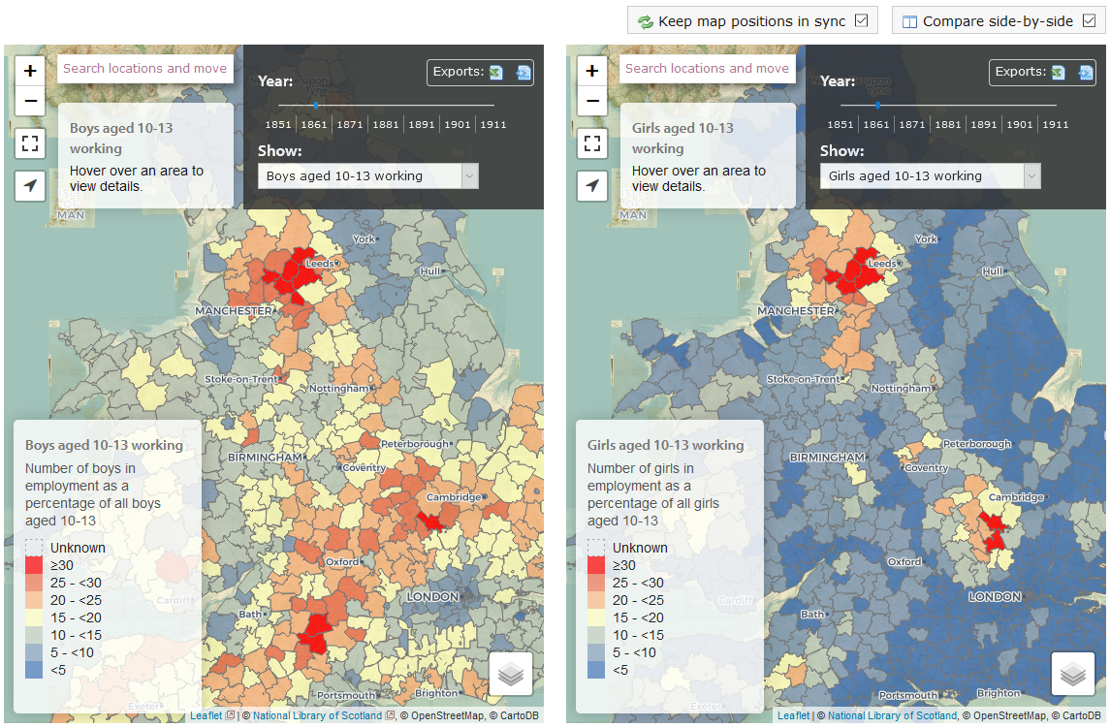

In Lancashire (the area north of Manchester) there were plentiful job opportunities for children in textile manufacturing factories, although a series of Acts of Parliament gradually raised the minimum age that children could be employed from (age 10 in 1878, age 11 in 1891 and age 12 in 1901) . Other major employment opportunities for children included straw-plaiting in Bedfordshire, agricultural work in rural areas, and domestic service.

## Activities:

**What were the levels of children’s work like in your area in the nineteenth century?**

**What kinds of work do you think children were doing?**

**The Year 8s also noticed that far more boys were doing paid work than girls.**

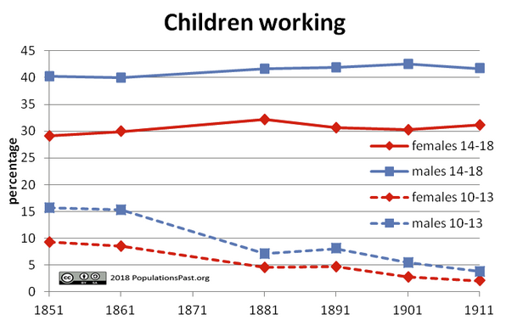

**Isabella said:**

Overall, there were many more boys working than girls

## Activities:

**Not all areas had large differences between boys and girls working. Which areas had similar levels?**

**Was there a big gap between girls and boys work in your area?**

**What other kinds of (unpaid) work do you think girls were doing?**

If I were to look further at today's dates it is likely there would be nearly no children working from ages 14-18 and probably no children from ages 10-13 working at all. I find it interesting how children aren't allowed to work the same jobs now as kids did in 1861 and 1911. Did the government think that it was ok to let children work?

**Imogen noticed that although the percentage of children aged 10-13 who were working dropped between 1851 and 1911, there was little change in the percentage of children aged 14-18 working (around 40% of boys and 30% of girls). She contrasted this with today and commented on how this reflects big changes in the attitudes of society regarding childhood.**

The decline in children aged 10-13 years working is likely to be due to the increase in the minimum working age in factories, but changes in educational provision may also have played a part. Together these reflected a gradual change in way that childhood was perceived in the nineteenth century.

# Child health

Improving levels of child survival might also have changed attitudes towards children, making parents more confident about having fewer children and investing in those they had, for example by sending them to school.

**Lewys noted that in the nineteenth century, infant mortality rates were higher in urban areas than in the countryside.**

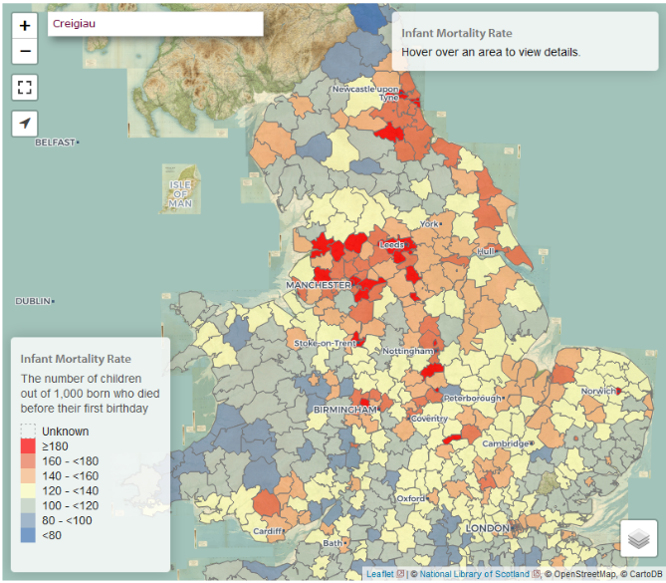

In 1851 infant mortality rates were higher in cities and towns where people lived in poor conditions where disease and hunger was high. This is especially noticeable in North West England due to the high population density and large cities and towns. I find this information interesting because it shows a clear link between history and data, and how it affects people lives.

**Seb noted that early child mortality (children aged 1-5) declined rapidly between 1851 and 1911.**

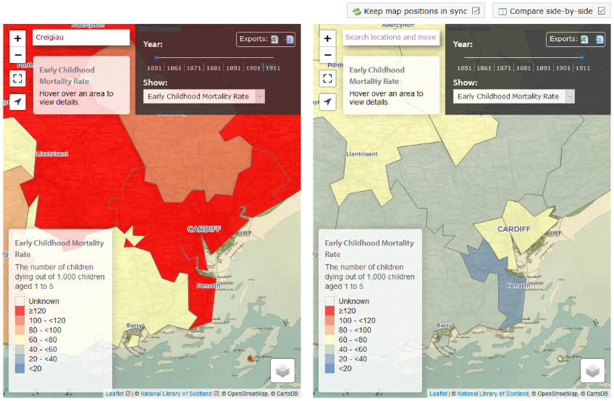

In the early 1800’s Cardiff had one of the highest young children death rates and by 1911 it had one of the lowest young child death rates.

## Activity:

**What was infant and early child mortality like in your area in the late nineteenth and early twentieth century?**

**Shane contrasted this with patterns of health in 2011. In his home area on the outskirts of Cardiff, over half the population reported having very good health, but in other areas of Cardiff less than a third of people reported very good health.**

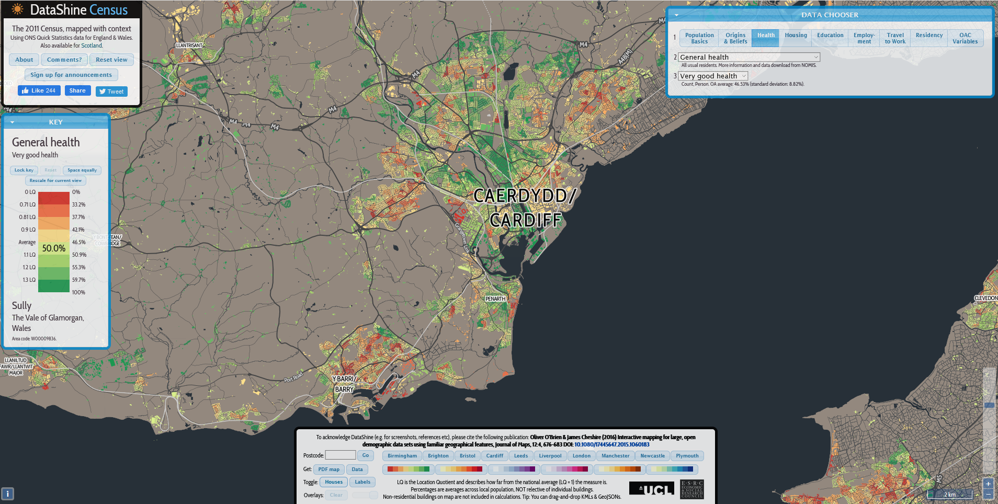

## Activity:

**Use** [**www.datashine.org.uk**](http://www.datashine.org.uk) **to explore levels of health in your area in 2011.**

Compare the geography of health in 1861 and 2011 in the maps below. These are different measures of health but they show some striking similarities as well as differences.

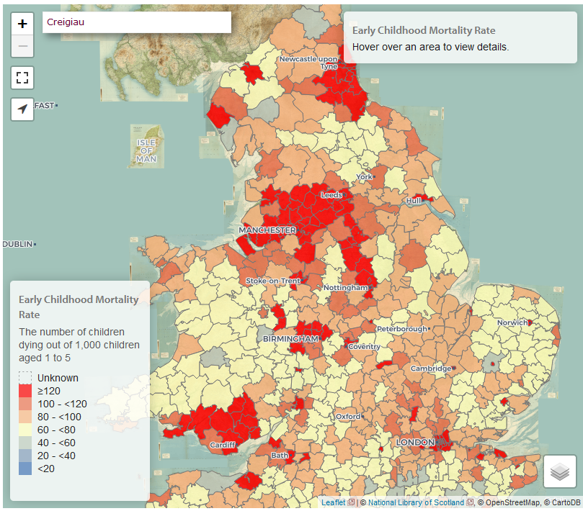 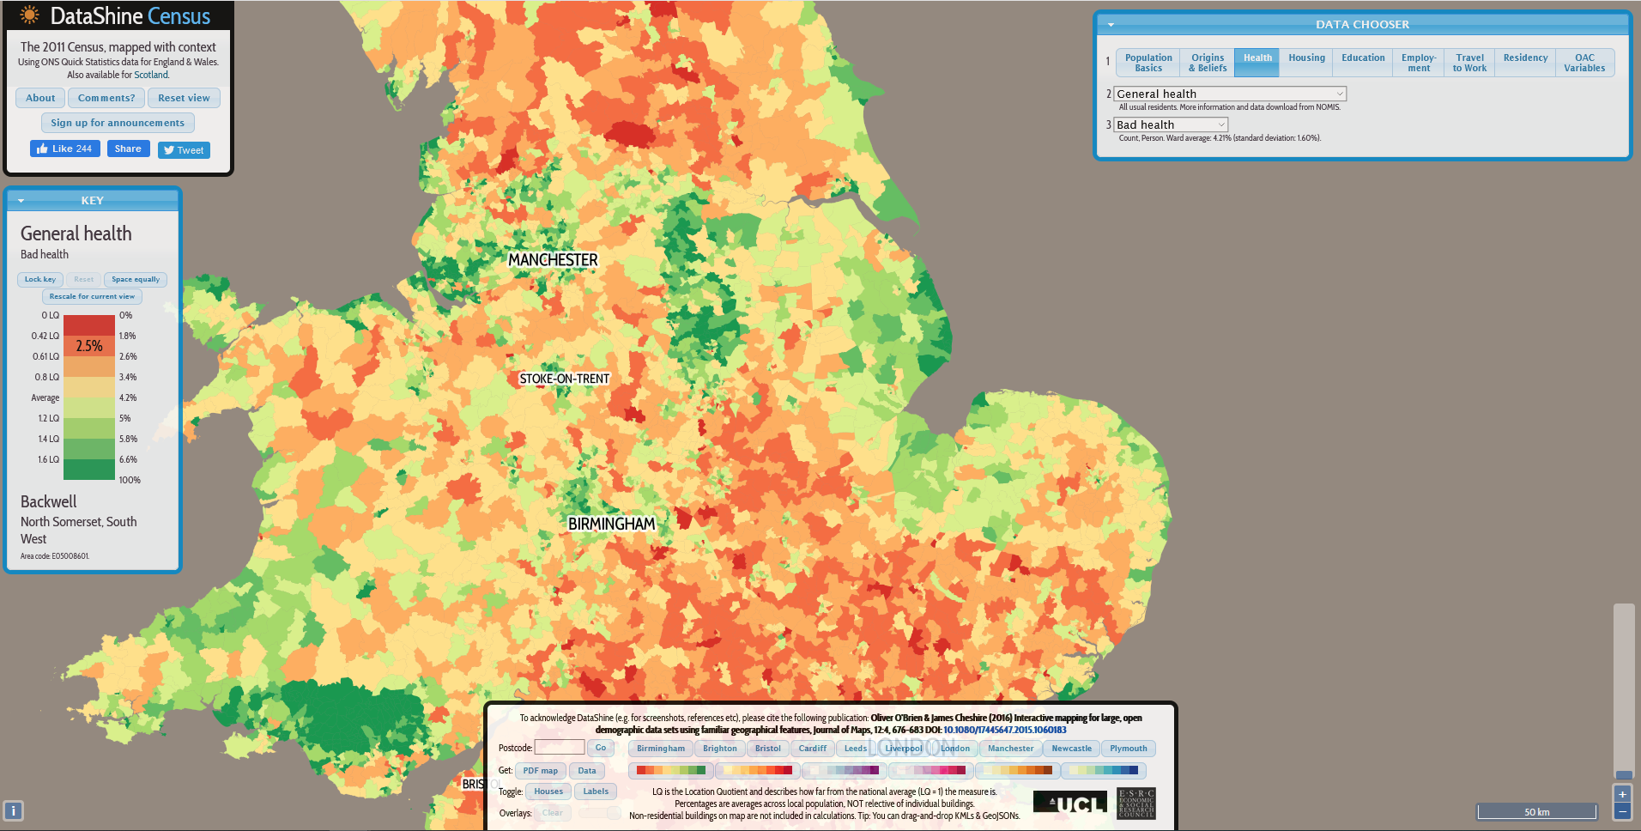

## Activities:

**Why did mining areas and industrial areas such as Lancashire, West Yorkshire, the Welsh Valleys and Durham have poor health in the past?**

**Why do you think they had poor health in 2011?**

# Types of place

S**eb noticed that PopulationsPast has categorized each place (put each place into a category) and has done so separately for each year. He said:**

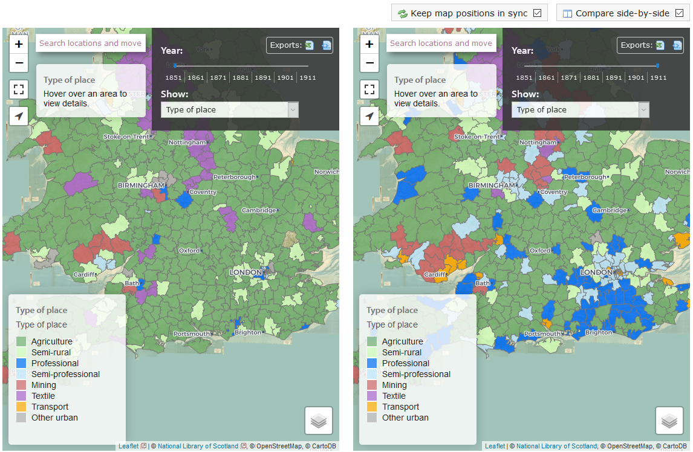

In 1851 the vast majority of places were agriculture but by 1911 London had turned to be professional and Cardiff was travel

Changes in the types of place over time reflect changes in the occupational and industrial structure of the country, urbanization and suburbanization.

**Oscar thought about this in relation to the changing distribution and percentage of men with professional occupations.**

In 1861, the number of Class 1 professional workers was highest in London. This is most likely because with London being the capital, and having the most expensive houses, more men would need a professional job rather than being a labourer to keep up their houses. However, over time the number of Class 1 workers spreads further around the UK, with big cities having the highest percentages of professional workers.

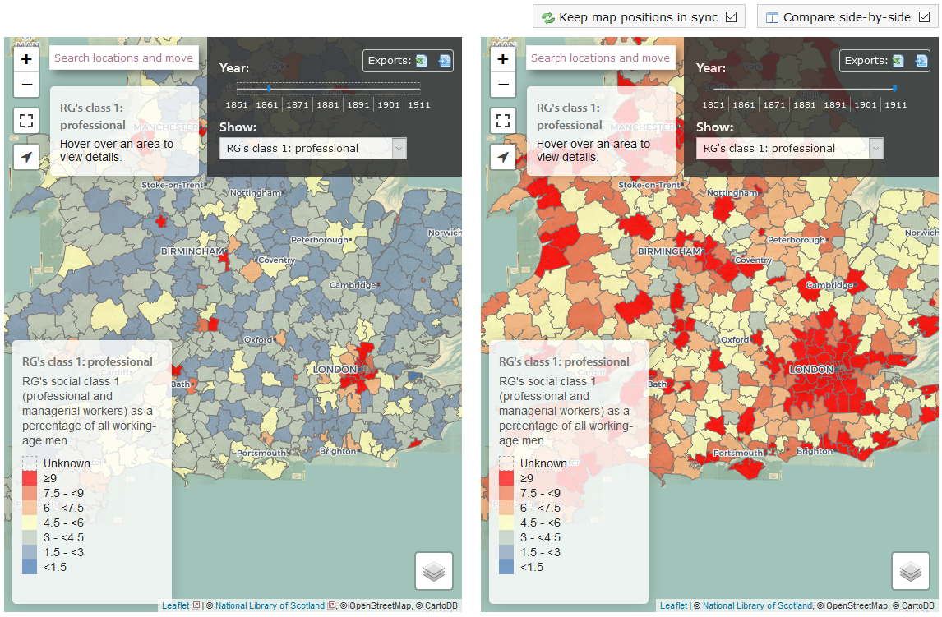

The type of jobs people do and how expensive a city is to live in is a bit of a chicken-and-egg situation. London has always been a financial centre, with relatively little industry, and this is likely to have affected the development of housing as well as attracting certain sorts of workers. If you look closely at London, however, you will see that there were areas with few professional people and many unskilled manual workers.

## Activity:

**Did other cities show geographical differences in where certain sorts of workers lived in the past? What about cities in 2011?**

# Servants

In the census, people were asked about their relationship to the household head, and some people stated that they were a servant. PopulationsPast has used this to identify households with live-in servants.

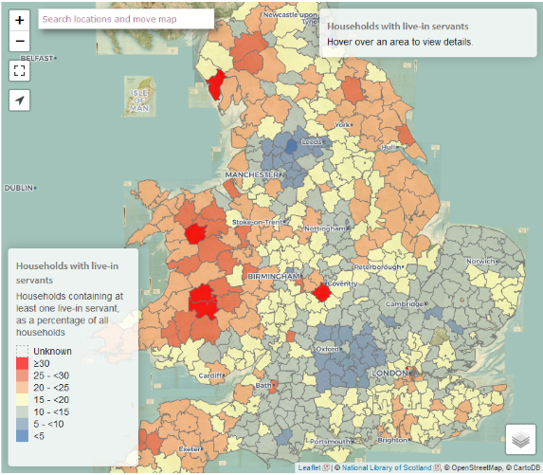**Seb noted that**

In 1851 Wales had lots of households with servants and parts of England didn’t have many at all. But by 1911 the number of servants everywhere dropped and South Wales and London had similar percentages.

When we interpret the map for 1851 above, we need to realise that there were two different types of servants: farm servants and domestic servants. Farm servants were employed on a farm but lived with the farmer’s family, while domestic servants were employed to do the cleaning, cooking and so on. Domestic servants were more common in urban areas and farm servants in rural areas, although of course rural female servants might have done both sorts of task.

The areas where there were very few servants were either highly industrial areas, or rural areas which had larger, arable farms which employed agricultural labourers instead of live-in farm servants.

## Activity:

**Did the area where you live have many servants or few? Why do you think this was?**

Being a servant was one of the main employment opportunities for women in the nineteenth and early twentieth centuries, and the textile industry (mainly in Lancashire and West Yorkshire) was another.

Some married women assisted their husbands in their business, and this was particularly common among shopkeepers and boarding house keepers. However most women stopped working when they got married: running a house and looking after children was hard enough without having to go out to work.

**Farida considered the difference between single and married women**:

I find the women's work category particularly interesting because I enjoy finding out about the different jobs women did in different periods of time and this included married and single ladies. I like to see the difference in lives between women who have children, are married and run a family and the ones who are independent and still exploring the world and themselves really and I think that the jobs those two people would have showed what style of life they were living. For example, in Loughborough in 1861, 31.62% of married women worked but the percentage of single women who worked was more than twice that, at 75.78%. This data shows married women had more responsibilities in the 1800s and single women had more freedom and independence as their responsibilities were themselves really.

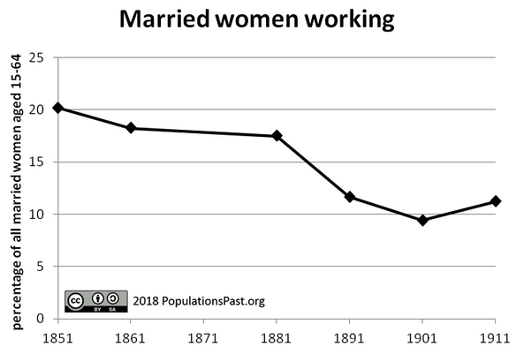**Angharad noticed that the percentage of married women who were working declined between 1851 and 1911**.

From 1851-1911, the number of married women between ages of 15-64 who were in work dropped, but could this could have been because of the way it was recorded on the census.

Angharad is right that changes in the way that the census asked questions about occupations affected some of this fall (in particular the sudden drop from 1881 to 1891) but there were also real changes linked to the rise of the 'male breadwinner ethic' and the 'cult of domesticity' which identified the home as the ‘proper’ place for a married woman.

## Activities:

**Have a look at women’s work for the area you live in. Were there many opportunities for women to work or few?**

**What sort of jobs do you think women were doing in your area in the nineteenth and early twentieth century?**

**It is much more acceptable today for women, including married women, to do paid work. Do you think there are still jobs which are seen as ‘women’s work’ or ‘men’s work’?**

# Marriage, families and households

Many people think that men and particularly women got married very young in the British past. In fact, between 1851 and 1881, the average age at first marriage was just over 25 years for women and around 26.5 for men.

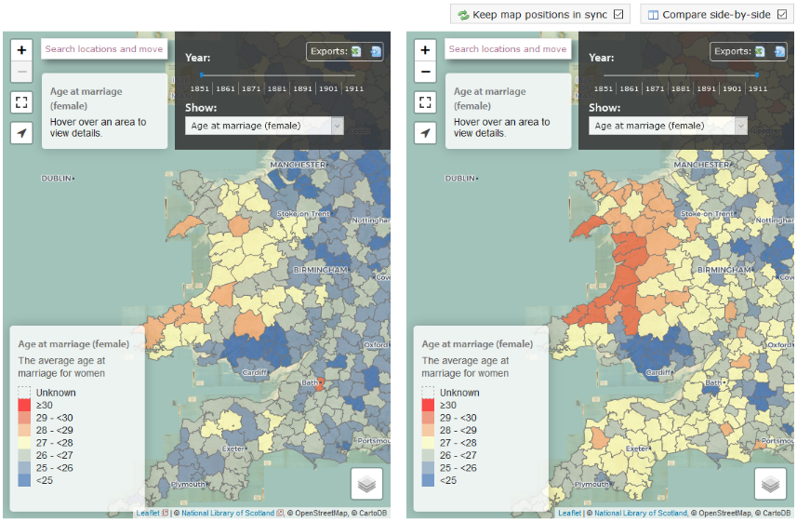**Seb noticed that the age at marriage increased in many places, but not everywhere, over this period.**

In 1851 the ages that women got married were relatively low in most places but by 1911 the ages increased lots except for in South Wales which stayed around the same.

## Activity:

**Why do you think women in South Wales (and other mining areas) continued to marry relatively early? (Hint: think about what other options there were.)**

In 1861 the lowest average age was in Merthyr-Tydfil and Neath. The average age was only 23.

**Oscar was intrigued by the average age of the population.**

Overall the average age between 1851 and 1881 was just under 26 years, but between 1881 and 1911 this increased to 28 years. This change is mainly the result of declining birth rates, which reduced the proportion of the population who were children.

By 1911 the areas with the lowest average ages were the places with the highest birth rates, which were mainly mining areas. This is linked to the low ages at marriage in these places because women who marry young have time to have more children.

You can also look at dependency ratios. Child dependency ratios were strongly linked to birth rates, but old age dependency ratios were affected by migration. When many young adults moved away from a place, the remaining population contained a smaller proportion of working age people and a larger proportion of older people.

## Activity:

**Look at the geographical patterns of the old age dependency ratio. Why do you think there were low old age dependency ratios in industrial areas and in London?**

Single person households have vastly increased in numbers in the past century.

**Zach looked at single person households over the last century, using PopulationsPast and DataShine. In 1911 6% of households contained a single person, but in 2011 this had risen to 30%.**

## Activities:

**Look at the geography of single person households: what sort of areas had the lowest percentages in 1911? What sort of places had the highest?**

**Was the pattern in 2011 similar or different?**

# Migration

**Indiana looked at the percentage of people who have a second address outside the UK and she thought carefully about what this might mean. She said:**

You can suggest that people who also live at a second address outside the UK are mainly adults looking for work to support their families back home. To support this suggestion, you can see on datashine.org.uk that people who also live at a second address outside the UK are mainly living in big towns and cities where there is lots of work opportunities. However, they are also living in coastal areas, but this can be explained because in these areas there are often big ports for boats and travel where work can easily be found. Sometimes you also find people with a second address outside the UK living in areas which don’t fit the two above categories, however most of these places are then known for a work industry (which could be in textiles or mining etc.) where people from abroad come to find a job.

Other people with a second address outside the UK might own a holiday home overseas, and many are students.

Datashine also allows you to look at the percentage of people in each area who were born in the UK (look at Residency>Length of residence in the UK>born in the UK), and this can also be examined in PopulationsPast.

## Activity:

**Look at the geographical patterns in the percentage of people born overseas in 1911 and 2011. Has this changed much?**